
The PsychOffice PLLC
New Patient Paperwork

Greetings!

We want to thank you for choosing The Psychoffice PLLC. for your mental health care needs. In our efforts to serve you, it is important that all items in this packet are complete, and ALL requested items are returned with the packet. Failure to do so will result in your packet being discarded.
***If you are seeking medication for ADHD, you must sign the controlled substance agreement attached. Please be aware that stimulant medication (Adderall) is not guaranteed to be given on the first visit. We conduct drug screens, check the national prescription monitoring program, and require a documented diagnosis. If you do not have a documented diagnosis, we will seek testing for you or conduct the assessment in our office. ***
A picture ID and a copy of the front AND back of your insurance card MUST be returned with the packet. All forms
MUST be completed, initialed, and signed. When returning the packet, you may:
- Mail it back to us at: your office location: The PsychOffice PLLC.
Address: 5900 Balcones Drive Suite 100,
Austin, Texas 78731

The PsychOffice PLLC.
7616 Branford Place, Suite 220
Sugar Land, Texas 77479

The PsychOffice PLLC.
5441 S Macadam Ave STE N
Portland, Oregon 97239

- Email it back to info@thepsychoffice.com or

We will call to get you scheduled once we have received and reviewed your paperwork. Please do not call the office to schedule, we will call you.
If you have a question about the paperwork, you may contact us at (346) 261-0342
Thank you,
The PsychOffice PLLC
Maj-Britt Larbi, PMHNP-BC

Page 1 of 26

(Please print clearly. The following information should pertain to the client.)

LAST NAME: FIRST NAME: MI:
DATE OF BIRTH: LEGAL GENDER: Male Female
ADDRESS:
CITY: STATE: ZIP:
PREFERRED PHONE: ALTERNATIVE PHONE:
SOCIAL SECURITY #: EMAIL:
SPOUSE / PARENTS NAME:
EMPLOYER: OCCUPATION:
EMERGENCY CONTACT NAME & RELATIONSHIP: PHONE NUMBER:
ETHNICITY: PREFERRED LANGUAGE: RACE:

RESPONSIBLE PARTY INFORMATION
LAST NAME: FIRST NAME: MI:
ADDRESS:
CITY: STATE: ZIP:
PHONE: RELATIONSHIP TO PATIENT:
ARE YOU CURRENTLY A PATIENT AT The PsychOffice PLLC: YES NO

INSURANCE INFORMATION
PRIMARY INSURANCE COMPANY:
POLICY #: GROUP #:
SUBSCRIBER NAME: SUBSCRIBER SSN#/DOB:
SUBSCRIBER EMPLOYER: SUBSCRIBER RELATIONSHIP TO PATIENT:

SECONDARY INSURANCE COMPANY (IF APPLICABLE):
POLICY #: GROUP #:
SUBSCRIBER NAME: SUBSCRIBER SSN#/DOB:
SUBSCRIBER EMPLOYER:
SUBSCRIBER RELATIONSHIP TO PATIENT:

Regarding Your Privacy
The PsychOffice PLLC abides by the Health Information Privacy Protection Act that governs how your medical information may be used and disclosed. Please read the attached Notice of Privacy Practices to learn how your information may be used. You may keep a copy of the notice for your records.

I acknowledge that I have read the Notice of Privacy Practices regarding my right to privacy while receiving services in this office.

Signature: Date:

(Parent or legal guardian if client is under the age of 18.)
Patient Name(print):

Credit Card Authorization Agreement

I , authorize The PsychOffice PLLC to use my credit card information to charge my credit card for co-payments, outstanding balances, and if I do not notify the office of my inability to attend scheduled appointments and/or do not cancel my appointment at least 24 hours in advance. The set cancellation fee is $75 unless otherwise agreed upon with my provider. I will not dispute charges (“Charge Back”) for sessions I have received or commitments I have missed according to the above policy. I understand that I can also choose to add my credit card to the electronic health record vault for this same purpose.

Card Type (circle one):
VISA MasterCard Discover American Express

Credit Card #: Expiration Date:

Name as Printed on Card:
Verification/Security Code (3-digit code on back of card by signature line):
*I would rather add my credit card information to the electronic vault: Yes: □ No: □
Billing Address:
City: State: Zip:

Phone Number: Email Address:

By signing below, I am authorizing The PsychOffice PLLC to charge for missed scheduled appointments with email confirmation and receipt.
Signature: Date:

Credit Card Authorization Agreement DENIAL

I DO NOT feel comfortable sharing my credit card information with The PsychOffice PLLC to be stored in their secure Electronic Health Record for the purpose of billing. I agree to receive paper and/or electronic statements for any charges that may be outstanding on my account. I agree to pay any unresolved balances once notified or make appropriate payment arrangements with their billing staff. Any balance that remains unresolved beyond 30 days is subject to past due penalties.

Signature: Date:

Consent for Release of Information

Patient: Date:

Patient Date of Birth:
Information to be released:

To: From:

Phone:
Fax:
Phone:
Fax:

Check One OR Both:
The PsychOffice PLLC is hereby authorized to release to the above person and/or facility the following (Check all that apply):
You are hereby requested to furnish The PsychOffice PLLC with the following (Check all that apply):
Evaluations
Psychological and/or education testing
Progress Notes
Medical Reports
Correspondence
Telephone Communications
Assessment/Treatment of Substance Abuse
Other:
Note: This authorization may be revoked at any time, except to the extent that action has been taken in reliance on it. If not otherwise specified, this authorization will expire one year from the date of signature of the patient/responsible party.

Patient / Responsible Party Signature Date / Time

Witness Signature Date / Time

Practitioner Requesting/ Sending Information

Financial Agreement

Insurance Information

(Please initial each applicable section)

As a courtesy, we will verify your insurance benefits before your initial visit. Any co-payment, coinsurance, or deductible we charge is based on the benefits provided by your insurance company(s). Patients are responsible for any outstanding balance if the insurance carrier denies benefits, changes co-payment, alters your deductible, retracts a payment, or does not provide benefits as estimated. Patients or the Responsible Party must pay the balance regardless of the reason the insurance company denies coverage.
I agree to pay my co-payment, coinsurance, and/or deductible at the time of service. I
^{(initial)} understand that services may be refused if payment is not made.

I agree to notify Geric New Dawn PLLC of any changes to my insurance policy. If
^{(initial)} I fail to do so; I understand that I may be responsible for the FULL standard fee for the appointment.
I agree to pay the $100.00 fee if I miss my appointment and $75 if I fail to give at least 24 hours’ notice
^{(initial)} of a cancellation. I understand that insurance companies do not cover the cost of late cancellations or missed appointments.

I agree to pay my balance in full once it comes to my attention, or I will follow the agreed upon
^{(initial)} payment plan on time until the balance is paid in full. I understand that failure to do so may result in suspension of services. I understand that my provider may be willing to work within my financial constraints and discussion of options is always the first option.
I agree to pay a $50.00 returned check fee in any instance where my check may be returned from my financial institution. I also agree that checks will no longer be accepted if this occurs.

Self-Pay Information:
I agree to pay the self-pay rate as listed below (i.e., no insurance or insurance is not accepted)
^{(initial)} Psychiatric Evaluation: $300
Medication Management Follow Up: $150

Additional Charges:
Services offered that incur additional charges are based upon time spent to complete the
^{(initial)} service include, but are not limited to:
- Letters (1-3 pages): $50.00
- Filing Forms: $25 per page
- FMLA / Disability Paperwork: Starts at $100.00
- Copying: $0.10 per page.
-Records $25.00 up to 25 pages, then 0.10 per page
*Payment for additional charges is due upon completion of the service.

Signature: Date:

(Parent or legal guardian if client is under the age of 18.)

Patient Policies and Procedures
Late Policy: We will allow a fifteen-minute window for all new patients and a six-minute window for all follow-up appointments. After allotted time, you will be marked a no-show and will be charged a $100.00 no-show appointment fee.

Refill Policy: Patients are usually scheduled in 30, 60, or 90-day increments. There will be NO refills provided without an appointment. If you miss your appointment, you may go to the ER or your PCP. Please make sure you receive enough medication to make it between each appointment. If you are going out of town, it is your responsibility to secure refills at least 72 hours in advance.

Paperwork Policy: The fee schedule for paperwork is in the Financial Agreement. You must be an established patient, which means at least 3 office visits prior to any FMLA, or Disability paperwork being filled out for you. It is always at the discrepancy of the provider whether paperwork will be filled out. Any patient who takes themselves out of work without the consent of their provider will NOT have FMLA paperwork filled out for them.

Prior Authorization(s): Please understand our office has 72 hours to process a prior authorization for your medication. Prior Authorizations for stimulant medications may require a drug screen. Also, it may take an additional 72 hours for your insurance to respond.
Thank you,
The PsychOffice PLLC

Signature: Date:

Definitions: With respect to this document, the following terms will apply:

I (patient):

My Provider:

Controlled Substance (Medications):

CONSENT TO TREATMENT AND/OR DRUG THERAPY:
I voluntarily request my provider to treat my condition(s). I hereby authorize and give my consent to administer or prescribe the prescription(s) for dangerous and/or controlled substance(s) (medication(s)) as part of therapy or treatment for my condition.

I understand that these medications may include opioid/narcotic, anti-anxiety, insomnia, ADHD, etc. drug(s), which can be harmful if taken without medical supervision. I further understand that these medication(s) may lead to physical dependence and/or addiction and may, like other drugs used in the practice of medicine, produce adverse side effects or results. Alternative methods of treatment, possible risks involved, and the possibilities of complications have been reviewed as listed below. I understand that this listing is not complete, and that it only describes the most common side effects or reactions, and that death is also a possibility as a result from taking these medication(s).

I HAVE BEEN INFORMED and understand that I will undergo medical tests and examinations before and during my treatment. Those tests include random unannounced checks for drugs on less than 24-hour notice and psychological evaluations if and when it is deemed necessary, and I hereby give permission to perform the tests, or my refusal may lead to termination of treatment. The presence of unauthorized substances or the absence of authorized medication(s) may result in my being discharged from my provider's care.

For female patients only:

To the best of my knowledge, I am not pregnant.
initials
If I am not pregnant, I will use appropriate contraception/birth control during my course of treatment. I understand the possible side effects of medication(s) and that, at present, there have not been enough studies conducted on the long-term use of many medication(s) i.e., opioids/narcotics to assure complete safety to my unborn child(ren). With full knowledge of this, I consent to its use. If I am pregnant or am uncertain, I WILL NOTIFY MY PROVIDER IMMEDIATELY.

For ALL patients:
I UNDERSTAND THAT THE MOST COMMON SIDE EFFECTS THAT COULD OCCUR IN THE USE OF THE DRUG(S) USED IN MY TREATMENT INCLUDE BUT ARE NOT LIMITED TO:

- Constipation
- Nausea or vomiting
- Excessive drowsiness or sleepiness
- Itching
- Urinary retention (inability to urinate)
- Orthostatic hypotension (low blood pressure)
- Irregular heartbeat
- Insomnia (inability to sleep)
- Depression
- Impaired judgment &/or reasoning
- Respiratory depression (slow or no breathing)
- Impotence
- Tolerance to medication(s)
- Physical and emotional dependence, addiction and/or insomnia (inability to sleep)
- Death

Version 10/21/2025



I UNDERSTAND that it may be dangerous for me to operate an automobile or other machinery while using the medication(s) and I may be impaired during all activities, including work.
The goal of this treatment is for the management of my condition to live a more productive and active life. I realize that I may have a chronic illness and there is a limited chance for complete cure, but the goal of taking medication(s) on a regular basis is to manage (but probably not eliminate) my condition so that I can enjoy an improved quality of life. I realize that the treatment for some will require prolonged or continuous use of medication(s), but an appropriate treatment goal may also mean the eventual withdrawal from the use of all medication(s). My treatment plan will be tailored specifically for me. I understand that I am expected to participate in a functionally restorative program that may include physical/occupational therapy and/or other psychological counseling as prescribed by my doctor. I understand that I may withdraw from this treatment plan and discontinue medication use. I understand that I will be provided medical supervision if needed when discontinuing medication use.

I UNDERSTAND that no warranty or guarantee has been made to me as to the results of any drug therapy or cure of any condition. The long-term use of medications to treat my condition may be controversial because of the uncertainty regarding the extent to which they provide long-term benefit. I have been given the opportunity to ask questions about my condition and treatment, risks of non-treatment and drug therapy, medical treatment or diagnostic procedure(s) to be used to treat my condition and the risks and hazards of such drug therapy, treatment and procedure(s), and I believe that I have sufficient information to give informed consent.
CONTROLLED SUBSTANCE AGREEMENT:
The following agreements are made between the Patient and Provider, as identified above, and outline the duties and expectations of each party and will be considered a binding agreement. This agreement will be part of the patient’s medical records.
I UNDERSTAND AND AGREE TO THE FOLLOWING: (please initial each after reading)
1. This Controlled Substance Agreement relates to my use of any and all medication(s) to manage my condition as prescribed by my provider.

2. All medication(s) and prescriptions for the treatment of my condition will be obtained from only my provider.
3. Medication(s) for the management of my condition will be provided by my provider so long as I follow the rules, terms and conditions specified in this agreement. Failure to comply with any of the rules, terms, and / or conditions of this agreement may result in discontinuation of the medication(s) and / or my discharge from my provider’s care and treatment.

4. Discharge from my provider’s care and treatment may be immediate for any criminal behavior.
5. All medication(s) prescribed by my provider and other medication(s) prescribed by other providers must be obtained at only one (1) pharmacy. I will provide my pharmacist with a copy of this agreement at the request of my provider.

6. I will use the medication(s) exactly as directed by my provider.

7. My progress will be periodically reviewed and, if the medication(s) are not improving my quality of life, the medication(s) may be discontinued by my provider.
8. Use of illegal substances, alcohol, and other mood-altering drugs can lead to dangerous side effects. I agree to submit to urine, oral, and / or blood screens to detect the use or non-use of non-prescribed and prescribed medication(s) at any time and without prior warning on less than 24-hour notice. Any evidence of use of illegal substances will lead to discontinuation of the medication(s).

9. My provider may at any time choose to discontinue the medication(s) for the treatment of my condition.
10. I will disclose to my doctor all other medication(s) that I take at any time, prescribed by any doctor other than my provider.
11. I agree that I shall inform any doctor who may treat me for any other medical problem(s) that I am taking medication(s) for the management of my condition since the use of other medication(s) may cause harm.
12. I will stop all other medication(s) for the management of my condition unless otherwise directed by my provider.

13. I agree to inform my provider of any scheduled surgeries and / or procedures in a timely manner to allow any alterations of the medication(s) dosage.

14. I will not share, sell, or otherwise permit others, including my family and friends to have access to my medication(s).
15. I will keep my medication(s) and prescriptions in a secure place to prevent theft or loss. I will not allow or assist in the misuse / diversion of my medication(s); nor will I give or sell them to anyone else. Lost or stolen medication(s) and / or prescriptions may not be replaced.

16. I agree not to obtain or seek to obtain any other medication(s) from any other source (including Emergency Department, “urgent care clinic,” etc.) without first contacting my provider. Information that I have been receiving other medication(s) prescribed by other doctors that has not been approved by my provider may lead to a discontinuation of the medication(s) and treatment.

17. I understand that the State tracks information provided by pharmacies regarding all controlled substance prescriptions. My provider may access this data at any time if there is concern that I may be violating this Controlled Substance Agreement.
18. I will notify my provider’s office during office hours at least three (3) business days in advance before running out of medication(s) so the appropriate refills can be made. No controlled medications will be ordered when the office is closed.

19. I understand that refills will NOT be ordered before the scheduled refill date even if my medication(s) runs out.
When traveling, arrangements may be made in advance of planned departure date.

20. If it appears to my provider that there are no demonstrable benefits to my daily function or quality of life from the medication(s), my provider may try alternative medication(s) or may taper me off all medication(s). I will not hold my provider liable for problems caused by the discontinuance of the medication(s).
21. I recognize that my condition represents a complex problem which may benefit from other therapies (i.e., physical therapy, psychotherapy, alternative medical care, etc.). I also recognize that my active participation in the management of my condition is extremely important. I agree to actively participate in all aspects of the management program recommend by my provider to achieve increased function and improved quality of life.

22. I understand and agree that a consult with or referral to an expert may be necessary such as submitting to a psychiatric or psychological evaluation by a qualified provider.
23. I hereby give my provider permission to discuss all diagnostic and treatment details with my other provider(s) and pharmacist(s) regarding my use of other medication(s) prescribed by other doctor(s).

24. I must keep all follow-up appointments as recommended by my provider or my treatment and / or medication(s) may be discontinued.

PREFERRED PHARMACY:
Name:

Location:
Phone: ( ) Fax: ( )

I certify and agree to the following:
- I am not currently using illegal drugs or abusing prescription medication(s) and I am not undergoing treatment for substance dependence (addiction) or abuse. I am reading and signing this informed consent and controlled substance agreement while in full possession of my faculties and not under the influence of any substance that might impair my judgment.

- I have been given an opportunity to ask questions about my condition, alternative forms of treatment and risks of non-treatment, the medication(s) to be used, the risks and hazards involved, and all other provisions contained in this Controlled Substance Agreement. All my questions have been answered to my satisfaction and I have sufficient information to give this informed consent.

- I certify this form has been fully explained to me, that I have read it or have had it read to me, that the blank spaces have been filled in, and that I understand its contents.

- I agree to the use of the medication(s) in the treatment of my condition and to the terms of this informed consent and Controlled Substances Agreement.

PATIENT/OTHER LEGALLY RESPONSIBLE PERSON:

Signature Print Name

Date: Time: A.M. / P.M.

WITNESS/PROVIDER:

Signature Print Name

The PsychOffice PLLC

Definitions: With respect to this document, the following terms will apply:

I (patient):

My Provider:

Telepsychiatry Contract and Informed Consent:
Telepsychiatry is the delivery of psychiatry (or psychotherapeutic) services using interactive audio and visual (video) electronic systems where the provider and the patient are not in the same physical location. The interactive electronic systems incorporate network and software security protocols to protect patient information and safeguard the data exchanged.

Requirements:
- A computer and a webcam with microphone to video conferencing using a HIPAA compliant online company specializing in telemedicine.

Potential Benefits:
- Telepsychiatry eliminates barriers to accessing healthcare and provides alternative means to obtain behavioral health services for patients who may otherwise have limited accessibility or encounter prolonged waiting lists in the community.
- In addition to removing the burden of travel time to a physical medical office as well as the risks and costs associated with transportation, tele-mental health allows for flexible scheduling.
- Tele-mental health offers a reduction of stigma by providing private treatment in the comfort of the patient’s personal space.
- Tele-mental health can provide treatment for patients with disabilities and limited mobility without requiring extensive planning for transport.

Potential Risks:
- Telepsychiatry audiovisual equipment may experience technical difficulties.
- While every precaution is taken to secure patient data and maintain confidentiality, the nature of electronic appointments results in additional exposure to security breaches.
- Telepsychiatry may not be suitable for certain illnesses that require higher levels of care.
- Certain illnesses may not be adequately treated by telepsychiatry.
- It is the discretion of the mental health provider regarding continuation of tele-mental health services.

Medication Prescribing:
- All medications prescribed by the mental health provider will be sent electronically to the pharmacy on file.
- Controlled substances such as stimulants, benzodiazepines, and hypnotics will be prescribed at the provider’s discretion. A Controlled Substance Contract must be completed by the client and faxed/mailed/delivered to The PsychOffice PLLC prior to controlled substance prescriptions being provided.
- All clients prescribed controlled substances must be present in person at The PsychOffice PLLC. or an affiliate lab entity to complete a set of vital signs and/or urine drug screen prior to prescriptions being sent to the pharmacy.

Required Information on Every Visit:
- Name, location, and telephone number of the patient at the time of session. This is to ensure that your provider is aware of alternative means of treatment should an emergency occur.

Activities Permitting During Telemedicine Services
- Prescription refills will be permitted at the time of the appointment.
- Appointment scheduling can be done outside of the appointment through the patient portal.

Responsibilities of the Provider:
- The PsychOffice PLLC reserves the right to assess suitability and appropriateness of telepsychiatry candidates due to the potential limitations of the treatment modality mentioned above.
- In the event of imminent danger, the provider is legally and ethically bound to report information to authorities, family members, or others, to minimize potential harm.

Responsibilities of the Patient:
  - I agree to take full responsibility for the security of any communication or treatment information involved with my own computer and with my own physical location.
  - I understand that I, NOT the provider, am responsible for providing and configuring any electronic equipment used on my computer which is used for telepsychiatry. I understand that it is my responsibility to ensure the proper functioning of all electronic equipment before my session begins.
  - I understand that I must be seen face-to-face at least one time per year.
  - I understand that it is my responsibility to verify insurance coverage/eligibility for telepsychiatry treatment.
  - I agree to either provide the office with vital signs obtained from a PCP/Specialist’s office or appear to The PsychOffice PLLC. within one week before or after the scheduled telepsychiatry appointment for vital signs.

For ALL patients:
I UNDERSTAND THAT I HAVE THE FOLLOWING RIGHTS WITH RESPECT TO TELEMEDICINE:

- I have the right to withhold or withdraw consent at any time without affecting my right to future care or treatment nor risking the loss or withdrawal of any program benefits to which I would otherwise be entitled.
- The laws that protect the confidentiality of my medical information also apply to telemedicine. As such, I understand that the information disclosed by me during my treatment is generally confidential. However, there are both mandatory and permissive exceptions to confidentiality, including, but not limited to reporting child, elder, and dependent adult abuse; expressed threats of violence towards an ascertainable victim, and where I make my mental or emotional state an issue in a legal proceeding.
- I understand that I have a right to access my medical information and copies of medical records in accordance with the state law.
- I understand that all of the clinic policies of The PsychOffice PLLC. apply to all telemedicine visits as well as all in- person visits.

Cancellation and Late Policy:
  - All appointments must be cancelled twenty-four (24) hours in advance of the scheduled appointment.
  - Late cancellations in less than 24 hours will be charged $75.
  - A charge of $100 will be applied to the client’s account for lack of or inappropriate notification of a missed appointment.
  - Missed appointments are disadvantageous to your provider and The PsychOffice PLLC. Multiple missed/no- show appointments may result in discharge.

I certify that I have read and understand the entirety of this document, titled “Telepsychiatry Contract and Informed Consent.” By signing below, I agree with this document, put forward by The PsychOffice PLLC., and I am also authorizing The PsychOffice PLLC to use telepsychiatry for my evaluation and treatment.

PATIENT/OTHER LEGALLY RESPONSIBLE PERSON:

Signature Print Name

Date: Time: A.M. / P.M.

WITNESS/PROVIDER:

Signature Print Name

The PsychOffice PLLC

Teaching Facility Acknowledgement
Dear Patient,
The PsychOffice PLLC is a teaching facility. During your treatment you may encounter students on their various journeys in a variety of titles. Please understand that your care is our number one priority, and the quality of care provided will continue to be excellent. All students will be under direct supervision and will never be allowed to practice independently. The types of students you may encounter are Psychiatric Mental Health Nurse Practitioners (PMHNP). Thank you for your understanding in this matter and in our desire to prepare and mentor future mental health professionals.

Patient Acknowledgement

The PsychOffice PLLC Consent and Authorization for Electronic Communication
(E-mail and Text)
E-mail and text communication provides for a fast and easy way to communicate with your healthcare provider for those issues that are non-emergent, non-urgent or non-critical. It is not a replacement for interpersonal contact, that is the very basis of the patient-healthcare provider relationship; rather it can support and strengthen an already established relationship.
The following summarizes the information you need to determine whether you wish to supplement your healthcare experience at our practice by electronically communicating with staff members.
General Considerations
- E-mail communication will be considered and treated with the same degree of privacy and confidentiality as written medical records.
- Standard e-mail services, such as Gmail, AOL, Yahoo, and Hotmail are not secure. This means that e-mail messages are not encrypted and can be intercepted and read by unauthorized individuals.
- Transmitting e-mail that contains protected health information through an e-mail system that is not encrypted does not meet the security guidelines as required by the Health Information Protection and Accountability Act (HIPAA).
- Your E-mail address will not be used for external marketing purposes without your permission. You may receive a group mailing from the practice; however, the recipients e-mail addresses will be hidden.
Provider Responsibilities
- The Provider will attempt to electronically confirm your e-mail address by requesting a return response to all email messages.
- Your provider may route your e-mail messages to other members of the staff for informational purposes or for expediting a response.
- Designated staff may receive and read your e-mail.
- The provider will make every attempt to respond to your email within 1 business day. If you do not receive a response from the provider within 1 business day, please contact the office.
- Copies of e-mails sent and received from and to you will be incorporated into your medical record. You are advised to retain all electronic correspondence for your own files.
Patient Responsibilities
- E-mail messages should not be used for emergencies or time-sensitive situations. In the event of a medical emergency, you should contact 911. For emergent or time sensitive situations, you should contact your healthcare provider through the office.
- E-mail messages should be concise. Please arrange for an office appointment if the issue is too complex or sensitive to discuss via e-mail.
- Please key in your full name and the topic, i.e., medication question, in the subject line. This will serve to identify you as the sender of the e-mail.
- Please acknowledge that you received and read the provider’s message by return e-mail to the provider

CONSENT AND AUTHORIZATION FOR ELECTRONIC COMMUNICATION
(E-MAIL AND TEXT)
I have read and understood the above description of the risks and responsibilities associated with electronic communication with my healthcare provider.
I acknowledge that commonly used e-mail and cell phone services are not secure and fall outside of the security requirements set forth by the Health Insurance Portability and Accountability Act for the transmission of protected health information.
I have been given the opportunity to discuss electronic communication with my healthcare provider and have had all my questions answered.
In consideration of my desire to use electronic communication as supplement to in-person office visits with my provider, I hereby consent to electronic communication via non-secure e-mail services.
I understand that I may revoke my consent to communicate electronically at any time by notifying The PsychOffice PLLC in writing, but if I do, the revocation will not have any effect on actions my healthcare provider has already taken in reliance on my consent.
I agree to release my provider and the practice from any and all liability that may occur due to electronic communication over a non-secure network.
I further agree to be held accountable for the patient responsibilities as outlined above
Name____________________________________________________Date________________
Authorized Email Address:_______________________________________________________
I decline to use email as a form of communication:
Name____________________________________________________Date_______________

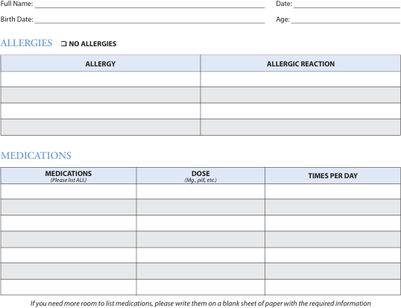
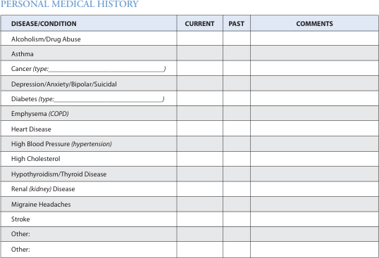


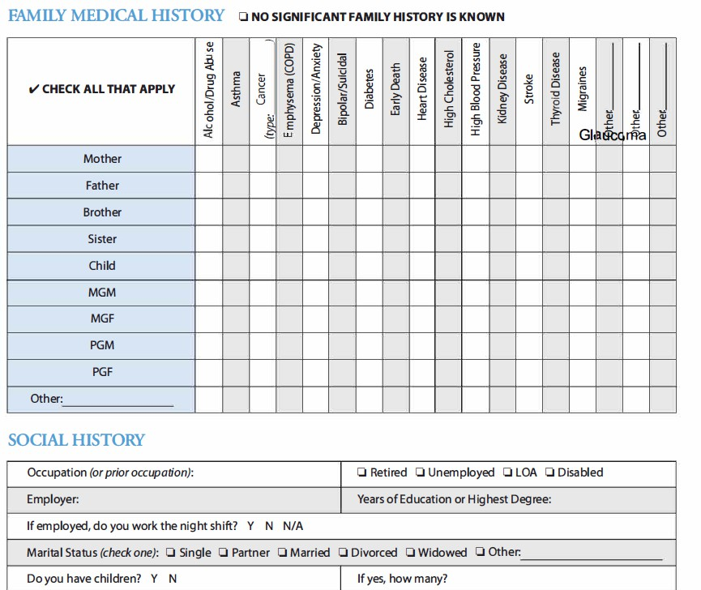
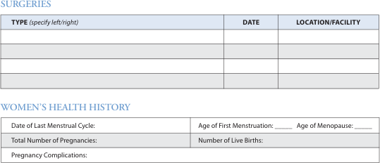

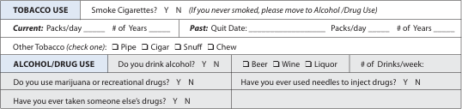

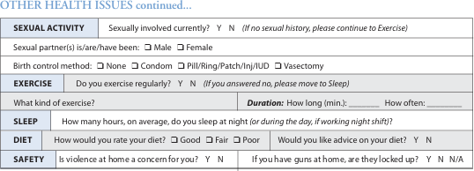

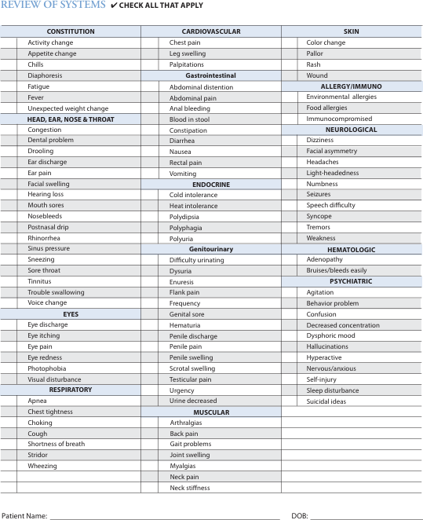

Patient Health Questionnaire and General Anxiety Disorder
(PHQ-9 and GAD-7)
Date Patient Name: Date of Birth:

Over the last 2 weeks, how often have you been bothered by any of the following problems? Please circle your answers.
PHQ-9 | Not at all | Several days | More than half the days | Nearly every day
1. Little interest or pleasure in doing things. | 0 | 1 | 2 | 3
2. Feeling down, depressed, or hopeless. | 0 | 1 | 2 | 3
3. Trouble falling or staying asleep, or sleeping too much. | 0 | 1 | 2 | 3
4. Feeling tired or having little energy. | 0 | 1 | 2 | 3
5. Poor appetite or overeating. | 0 | 1 | 2 | 3
6. Feeling bad about yourself – or that you are a failure or have let  yourself or your family down. | 0 | 1 | 2 | 3
7. Trouble concentrating on things, such as reading the newspaper or watching television. | 0 | 1 | 2 | 3
8. Moving or speaking so slowly that other people could have  noticed. Or the opposite – being so fidgety or restless that you have been moving around a lot more than usual. | 0 | 1 | 2 | 3
9. Thoughts that you would be better off dead, or of hurting yourself in some way. | 0 | 1 | 2 | 3
Add the score for each column

Total Score (add your column scores):
If you checked off any problems, how difficult have these made it for you to do your work, take care of things at home, or get along with other people? (Circle one)

Not difficult at all Somewhat difficult Very Difficult Extremely Difficult

Over the last 2 weeks, how often have you been bothered by any of the following problems? Please circle your answers.
GAD-7 | Not at all  sure | Several  days | Over half  the days | Nearly  every day
1. Feeling nervous, anxious, or on edge. | 0 | 1 | 2 | 3
2. Not being able to stop or control worrying. | 0 | 1 | 2 | 3
3. Worrying too much about different things. | 0 | 1 | 2 | 3
4. Trouble relaxing. | 0 | 1 | 2 | 3
5. Being so restless that it’s hard to sit still. | 0 | 1 | 2 | 3
6. Becoming easily annoyed or irritable. | 0 | 1 | 2 | 3
7. Feeling afraid as if something awful might happen. | 0 | 1 | 2 | 3
Add the score for each column

Total Score (add your column scores):

If you checked off any problems, how difficult have these made it for you to do your work, take care of things at home, or get along with other people? (Circle one)

Not difficult at all Somewhat difficult Very Difficult Extremely Difficult
UHS Rev 4/2020

Rapid Mood Screener (RMS)

Are you among the millions of people who have depressive symptoms? Answer the following questionnaire about your medical history and provide it to your doctor or nurse to assist in an important conversation about your mood.

Please select one response for each question. You can complete the RMS in less than 2 minutes.
Patient Name Date

YES | NO
1. Have there been at least 6 different periods of time (at least 2 weeks) when you felt deeply depressed?
2. Did you have problems with depression before the age of 18?
3. Have you ever had to stop or change your antidepressant because it made you highly irritable or hyper?
4. Have you ever had a period of at least 1 week during which you were more talkative than normal with thoughts racing in your head?
5. Have you ever had a period of at least 1 week during which you felt any of the following: unusually happy; unusually outgoing; or unusually energetic?
6. Have you ever had a period of at least 1 week during which you needed much less sleep than usual?

RMS Copyright © 2020 AbbVie. All rights reserved.
AbbVie Medical

Notice of Privacy Practices

OUR LEGAL RESPONSIBILITIES

We are required by law to give you this notice. It provides you with how we may use and disclose protected health information about you and describes your rights and our obligations regarding the use and disclosure of that information. We shall maintain the privacy of protected health information and provide you with notice of our legal duties and privacy practices with respect to your protected health information.

We have the right to change these policies at any time. If we change our privacy policies, we will notify you of these changes immediately. This current policy is in effect unless stated otherwise. If the policy is changed, it will apply to all your current and past health information.

You may request a copy of our notice any time. You may contact The PsychOffice PLLC at
7616 Branford Place, Suite 220 Sugar Land, Texas 77479 or 5900 Balcones Drive Suite 100, Austin, Texas 78731 or 5441 S Macadam Ave STE N. Portland, Oregon 97239 or via email: info@thepsychoffice.com or call (346) 261-0342 at any time to request a copy of this privacy policy.

HOW WE MAY USE OR DISCLOSE YOUR PROTECTED HEALTH INFORMATION

The following examples describe ways that we may use your protected health information for your treatment, payments, healthcare operations etc. but please be advised that not every use or disclosure in a particular category will be listed.

Treatment: We may use and disclose your protected health information to provide you with treatment. This includes disclosing your protected health information to other medical providers, trainees, therapists, medical staff, and office staff that are involved in your health care.

For example, your medical provider might need to consult with another provider to coordinate your care. Also, the office staff may need to use and disclose your protected health information to other individuals outside of our office such as the pharmacy when a prescription is called in.

Payment: Your protected health information may also be used to obtain payment from an insurance company or another third part. This may include providing an insurance company with your protected health information for a pre- authorization for medication we prescribed.

Health Care Operations: We may use or disclose your protected health information in order to operate this medical practice. These activities include training students, reviewing cases with employees, utilizing your information to improve the quality of care, and contacting you via telephone, email, or text to remind you of your appointments.

If we have to share your protected health information to third party “business associates” such as a billing service, if so, we will have a written contract that contains terms that will protect the privacy of your protected health information.

We may also use and disclose your protected health information for marketing activities. For example, we might send you a thank you card in the mail with a coupon for specialized services or products. We may also send you information about products or services that might be of interest to you. You can contact us at any point to stop receiving this information.

We will not use or disclose your protected health information for any purpose other than those identified in this policy without your specific, written Authorization. You may give us written authorization to use your protected health information or to disclose it to anyone for any purpose. You can revoke this authorization at any time but will not affect the protected health information that was shared while the authorization was in effect.

Appointment reminders: We may contact you as a reminder that you have an appointment for your initial visit, follow-up visit, or lab work via text, phone or email.

Others Involved in Your Health Care: We may disclose protected health information about you to your family members or friends if we obtain your verbal agreement to do so, or if we give you an opportunity to object to such a disclosure and you do not raise an objection. For example, we may assume that if your spouse or friend is present during your evaluation, we can disclose protected professional information to this person. If you are unable to agree or object to such a disclosure, we may disclose such information as necessary if we determine that it is in your best interest based on our professional judgment if there is an urgent or emergent need.

Research; We will not use or disclose your health information for research purposes unless you give us authorization to do so.

Organ Donation: If you are an organ donor, we may release protected health information to organizations that handle organ procurement or organ, eye or tissue transplantation if it is necessary to facilitate this process.

Public Health Risks: We may disclose your protected health information, if necessary, in order to prevent or control disease, report adverse events from medications or products, prevent injury, disability or death. This information may be disclosed to healthcare systems, government agencies, or public health authorities. We may have to disclose your protected health information to the Food and Drug Administration to report adverse events, defects, problems, enable recalls etc. if required by FDA regulation.

Health Oversight Activities: We may disclose protected health information to health oversight agencies for audits, investigations, inspections or licensing purposes. These disclosures might be necessary for state and federal agencies to monitor healthcare systems and compliance with civil law.

Required by Law: We will disclose protected health information about you when required to do so by federal, state and/or local law.

Workman’s compensation: We may disclose your protected health information to workman’s comp or similar programs.

Lawsuits: We may disclose your protected health information in response to a court action, administrative action or a subpoena.

Law Enforcement: We may release protected health information to a law enforcement official in response to a court order, subpoena, warrant, subject to all applicable legal requirements.

YOUR RIGHTS REGARDING YOUR PROTECTED HEALTH INFORMATION

Access to medical records: You have the right to access and receive copies of your protected health information that we use to make decisions about your care. You must submit a written request to obtain your protected health information to the individual listed at the end of this privacy policy. We reserve the right to charge you a fee for the time it takes to obtain and copy the protected health information and provide it to you.

Amendment: If you believe the protected health information, we have about you is incorrect or incomplete, you may ask us to amend the information. You will need to submit a written request on why you feel the health information should be amended. We may deny your request to amend if you did not send a written request or give a reason why it should be amended. If we deny your request, we will provide you with a written explanation. We may deny your request if we believe protected health information is accurate and complete.

Accounting of Disclosures: You have the right to receive a list of instances in which we disclose your personal health information unless the disclosure was used for treatment, payment, healthcare operations, was pursuant to a valid authorization and as otherwise provided in applicable federal and state laws and regulations. You must submit a written request to obtain this “accounting of disclosures” to the individual listed at the bottom of this policy. After your request has been approved, we will provide you the dates of the disclosure, the name of the individual or entity we disclosed the information to, a description of the information that was disclosed, the reason why it was disclosed, and any additional pertinent information. This information may not be longer than 6 years ago prior to the date the accounting is requested. We reserve the right to charge a reasonable fee for this process.

Restriction Requests: You have the right to request a restriction or limitation on the protected health information we use or disclose about you for treatment, payment, or healthcare operations. We shall accommodate your request except where the disclosure is required by law. We require this to be a written request submitted to the individual at the end of this policy.

Confidential Communication: You have the right to request that we communicate with you about healthcare matters in a certain way and at a certain location. We must meet your request if it is reasonable and allows us to continue to collect payments and bill you.

Paper copy of this notice: You may request a hard copy of this practice policy if you reviewed and signed it via electronic means. To obtain this copy, contact The PsychOffice at (346) 261-0342 or email info@thepsychoffice.com

Complaints: If you believe your privacy rights have been violated, you may file a complaint with our office. You also file a complaint with the U.S. Department of Health and Human Services. We will provide you with the address to file your complaint with the U.S. Department of Health and Human Services upon request.

